

**Ahsanullah University of Science and Technology (AUST)**

Department of Computer Science and Engineering

**LAB REPORT**

**Course No:** CSE2210

**Course Title:** Digital Electronics and Pulse Techniques Lab

**Experiment Number:** 04

**Name of the Experiment:** Study of a RTL NOR gate.

|  |  |
| --- | --- |
| **Group Number:** | 02 |
| **Report Writer:** |  |
| 18.01.04.005 | Mustofa Ahmed |
| **GroupMembers:** |  |
| 18.01.04.006 | Samia Sabrina Nabi |
| 18.01.04.007 | Tanjila Sultana Joti |

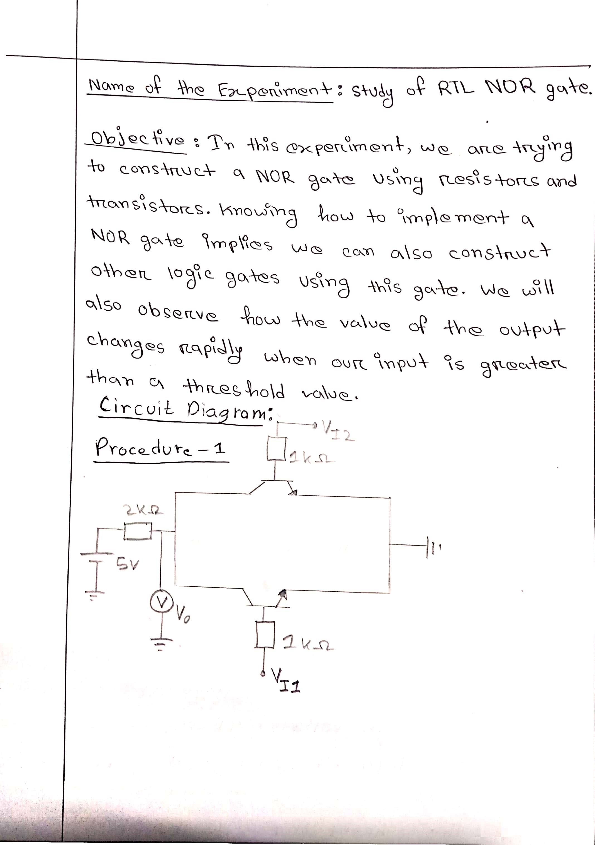

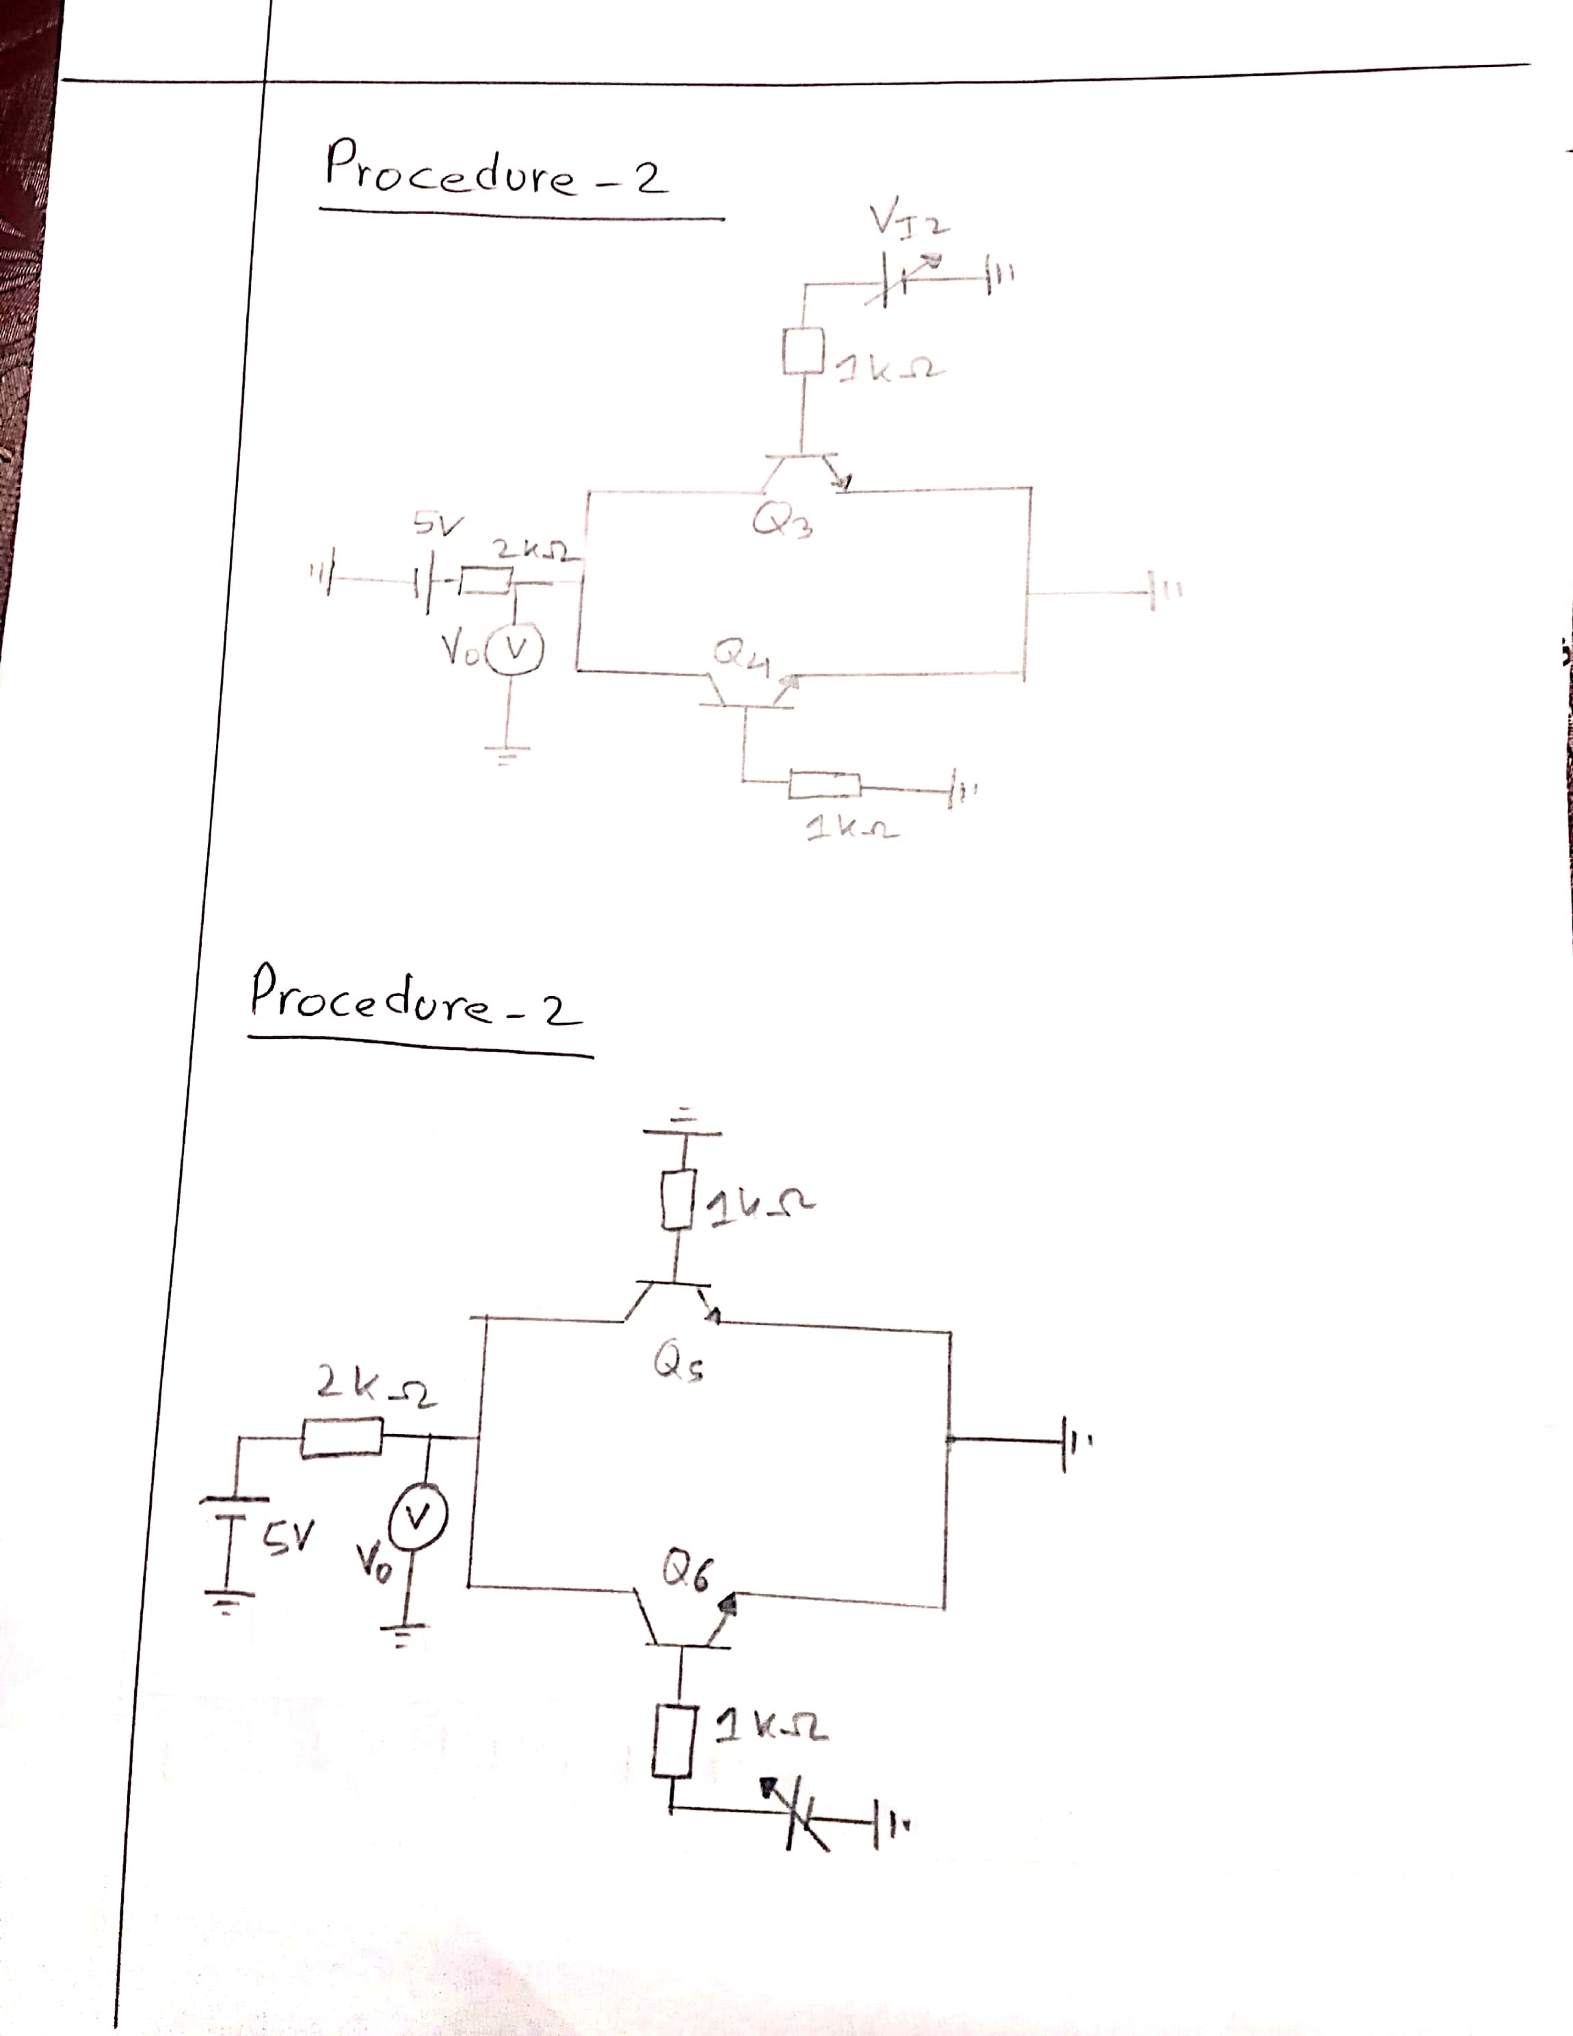

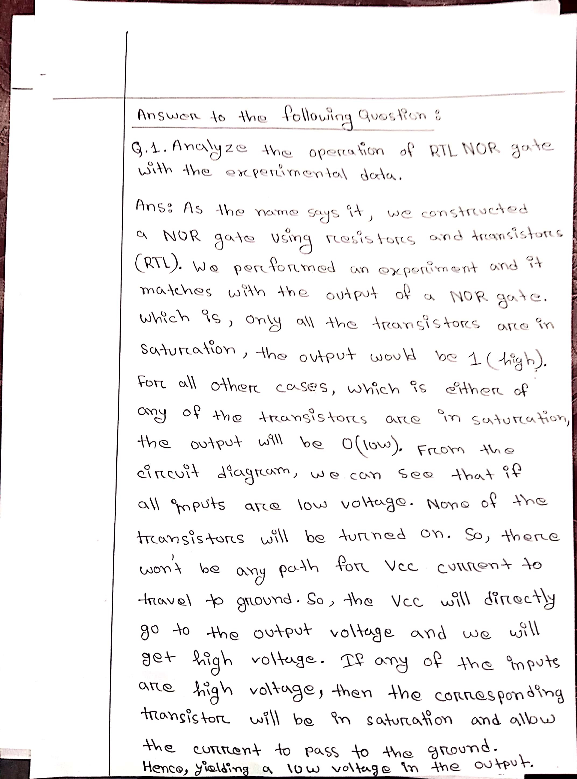

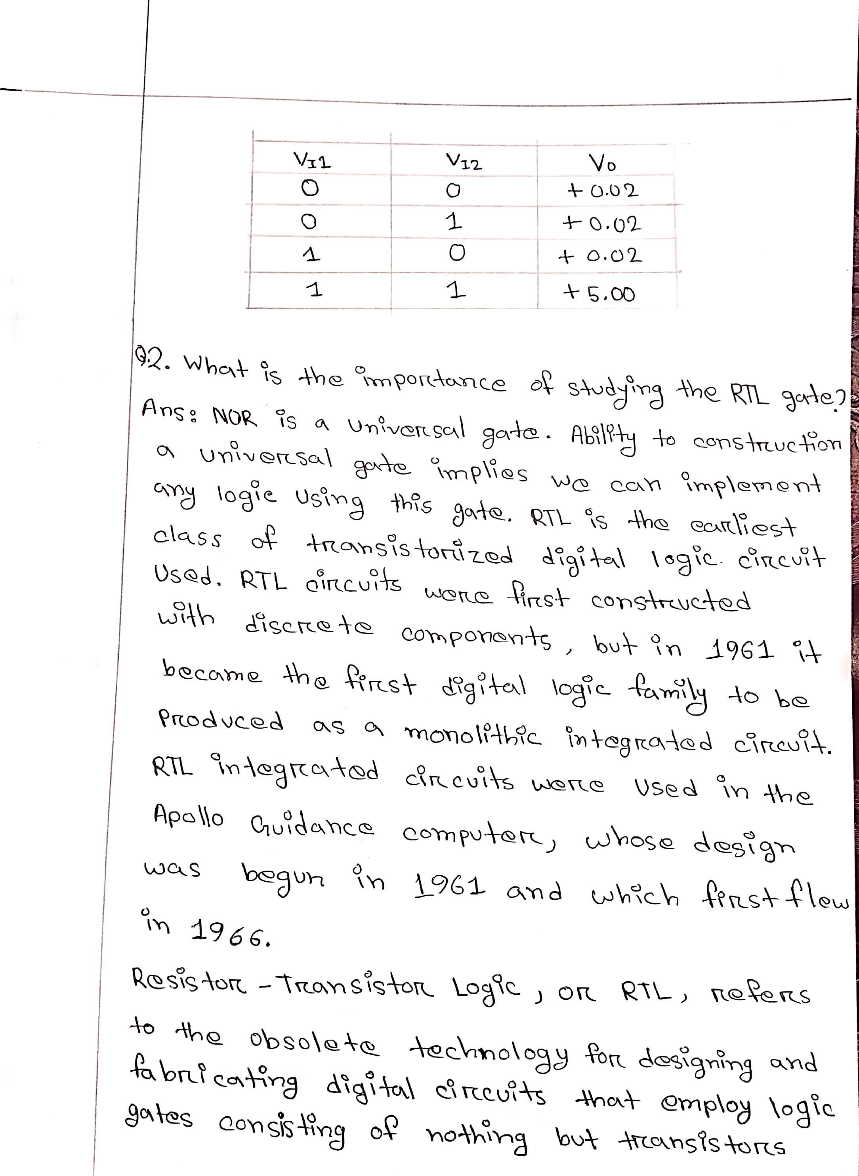

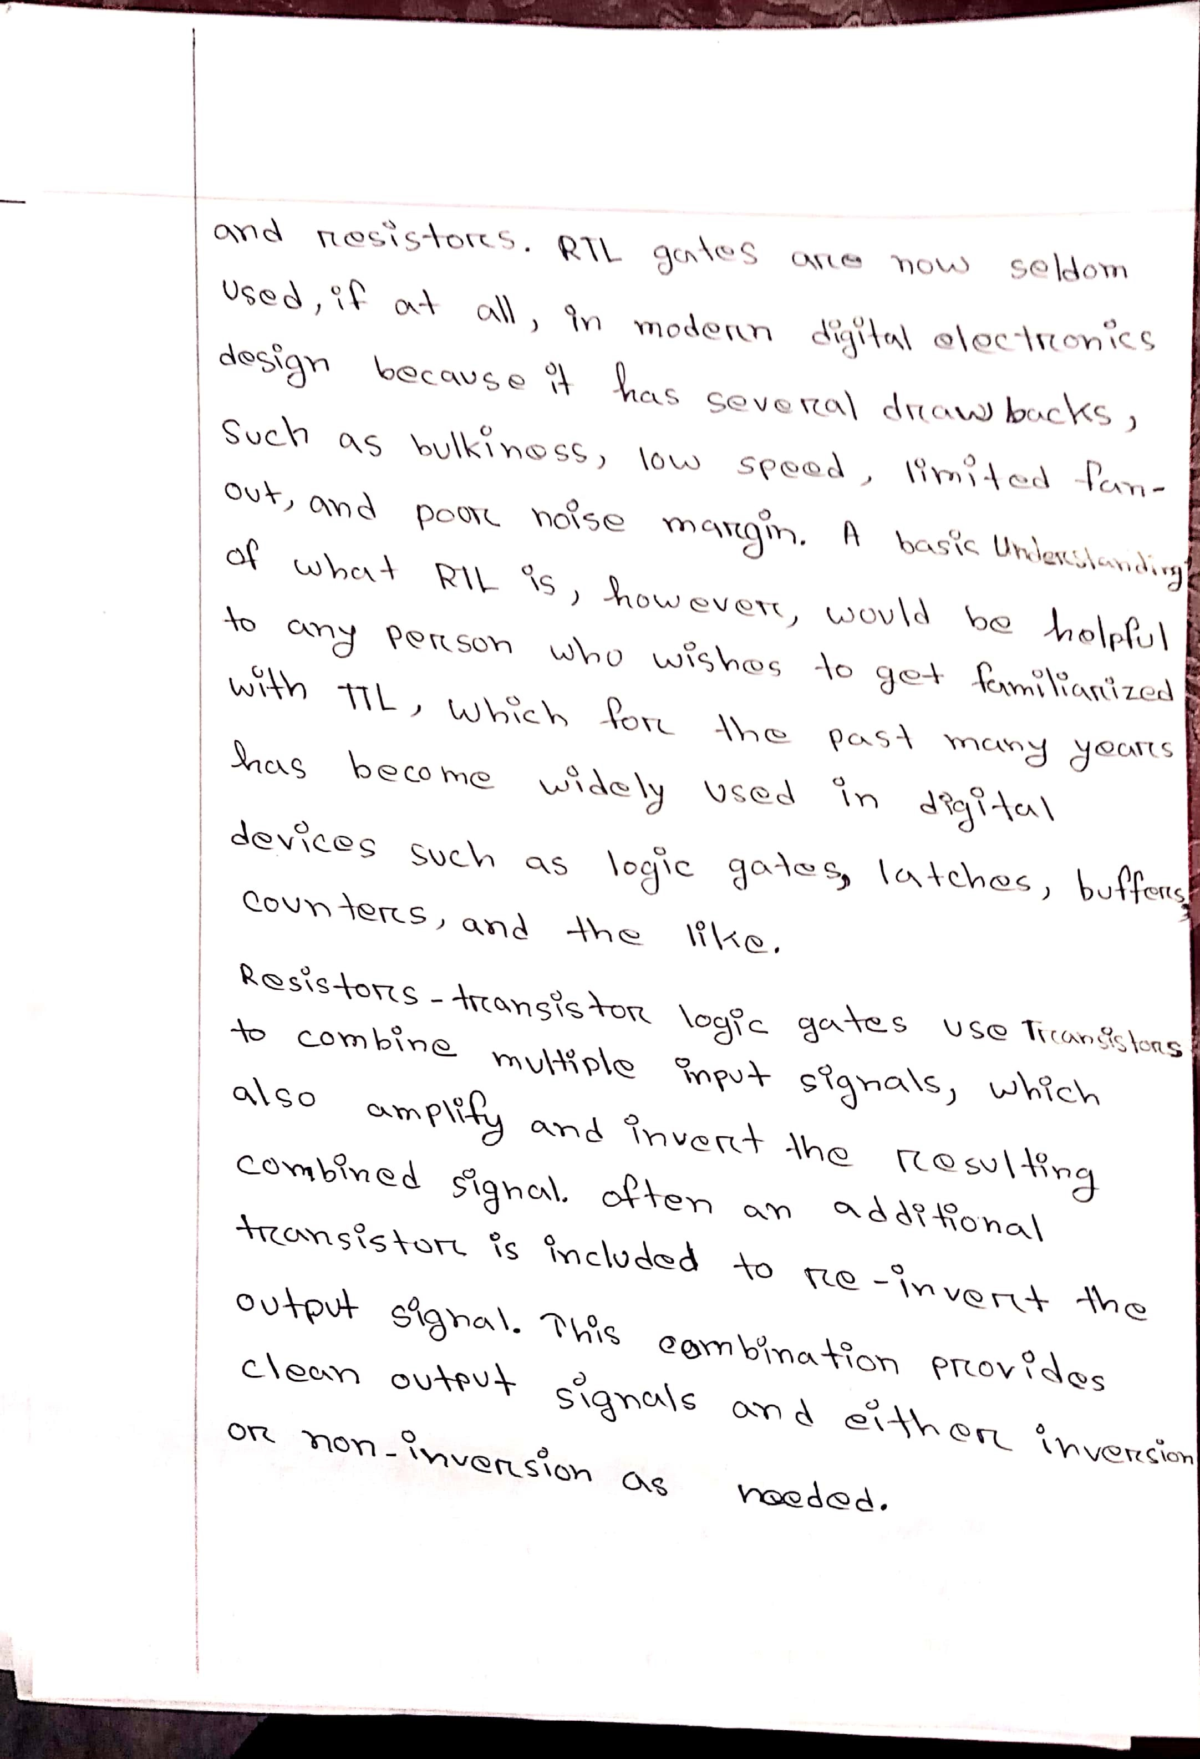

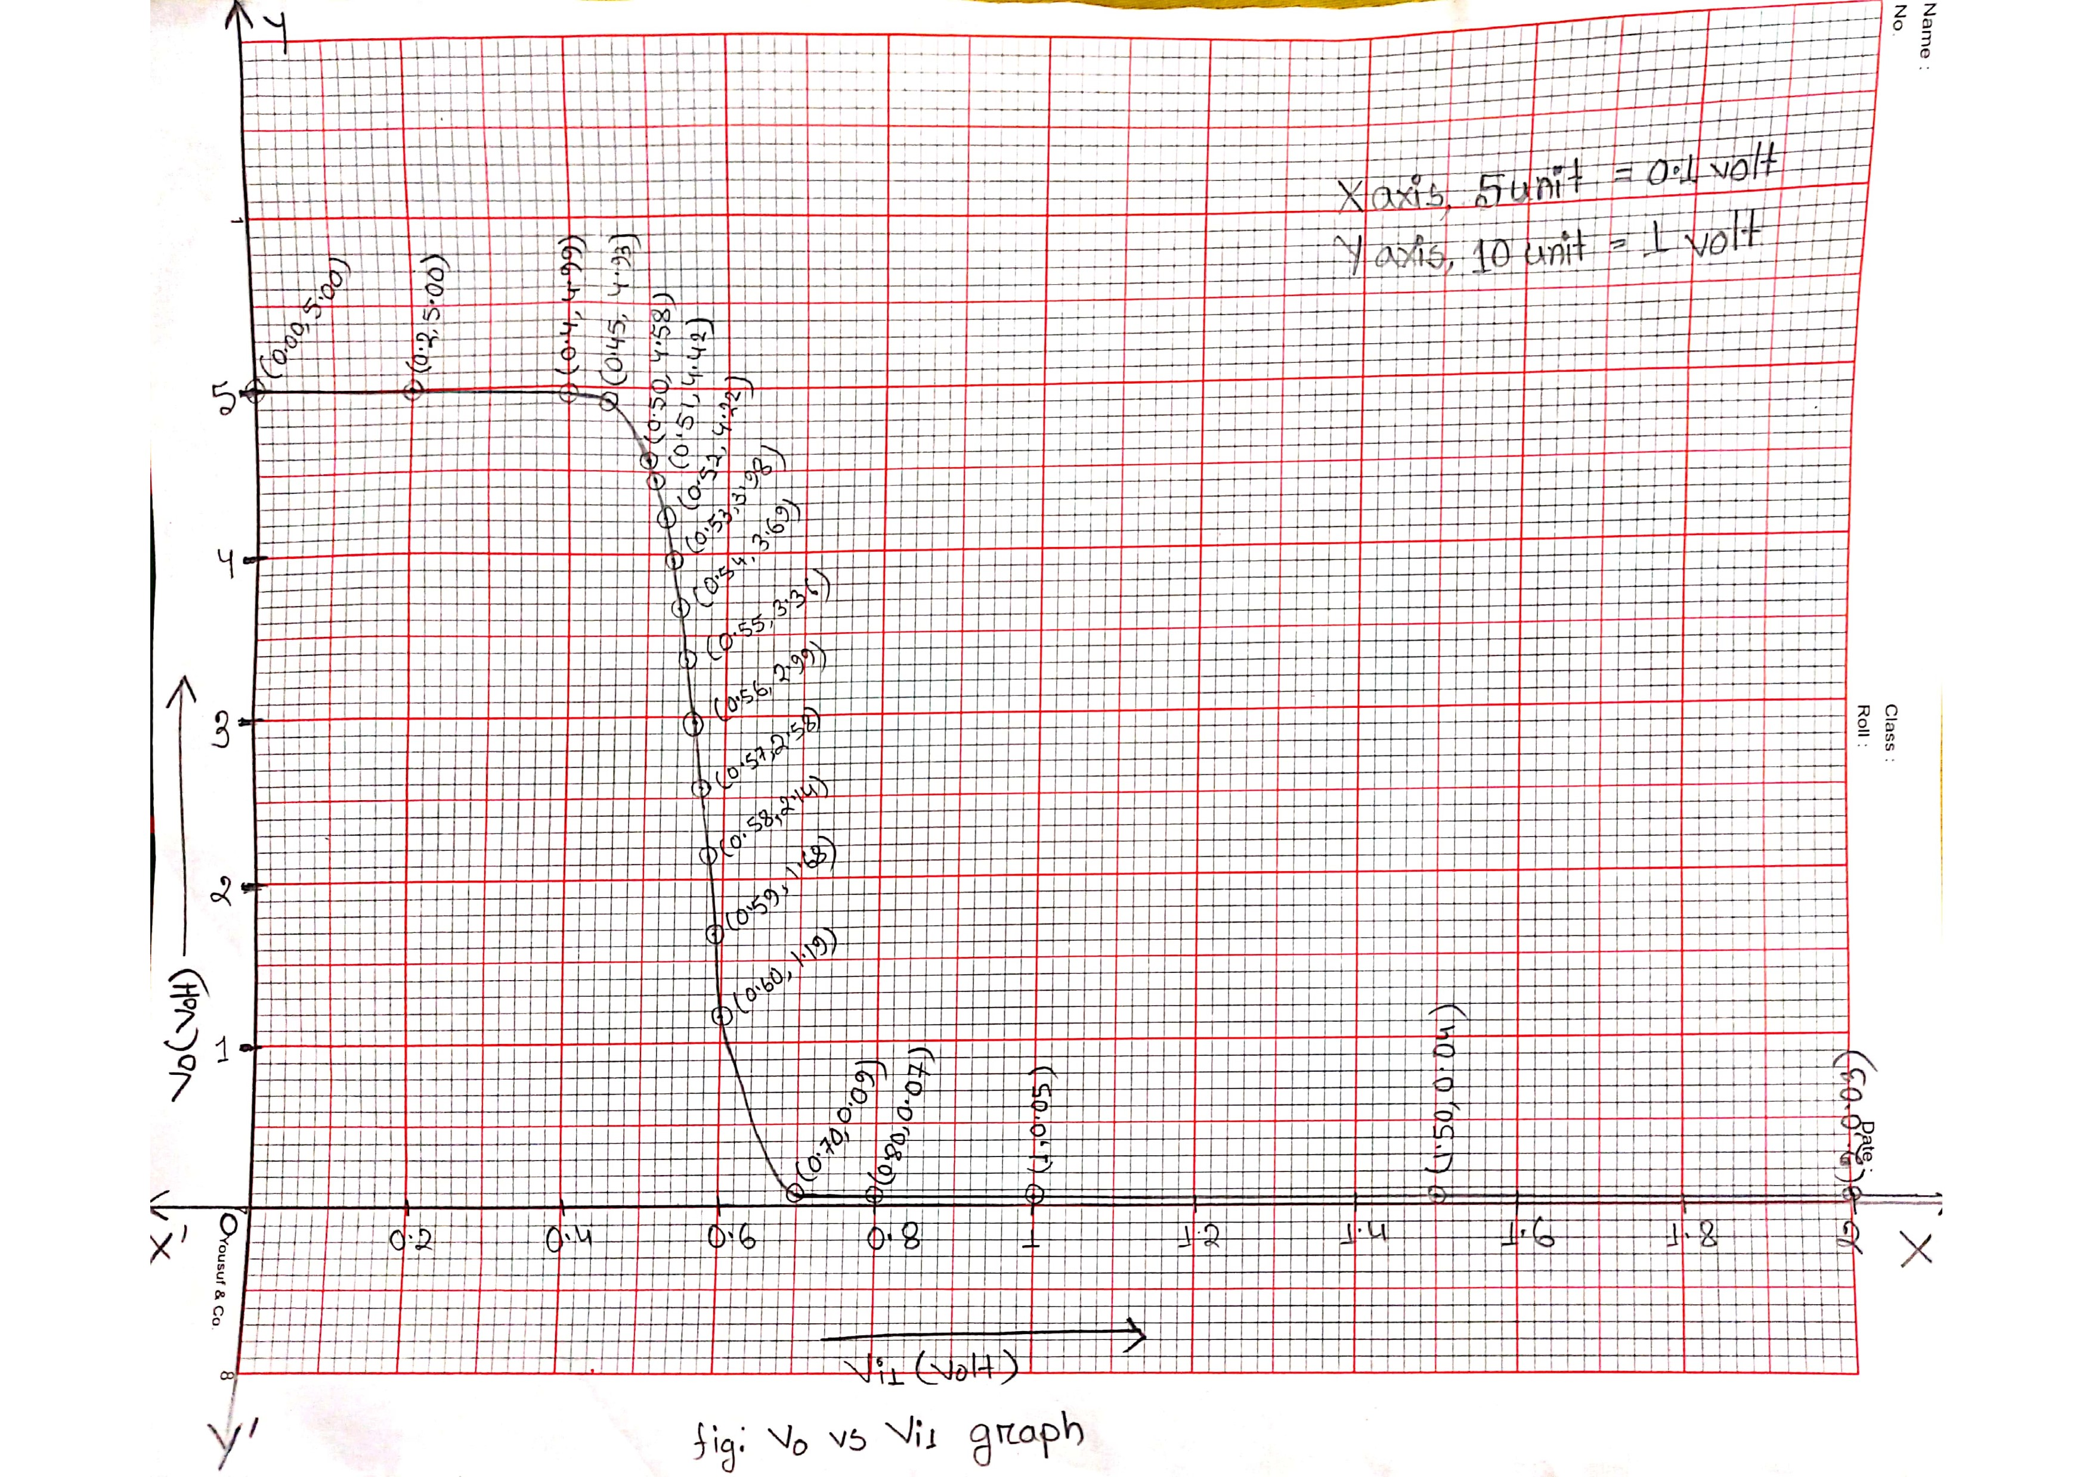

Graph of V0 vs Vi1

Q.3 Draw the V0 vs. Vi1 and Vi2 curves.

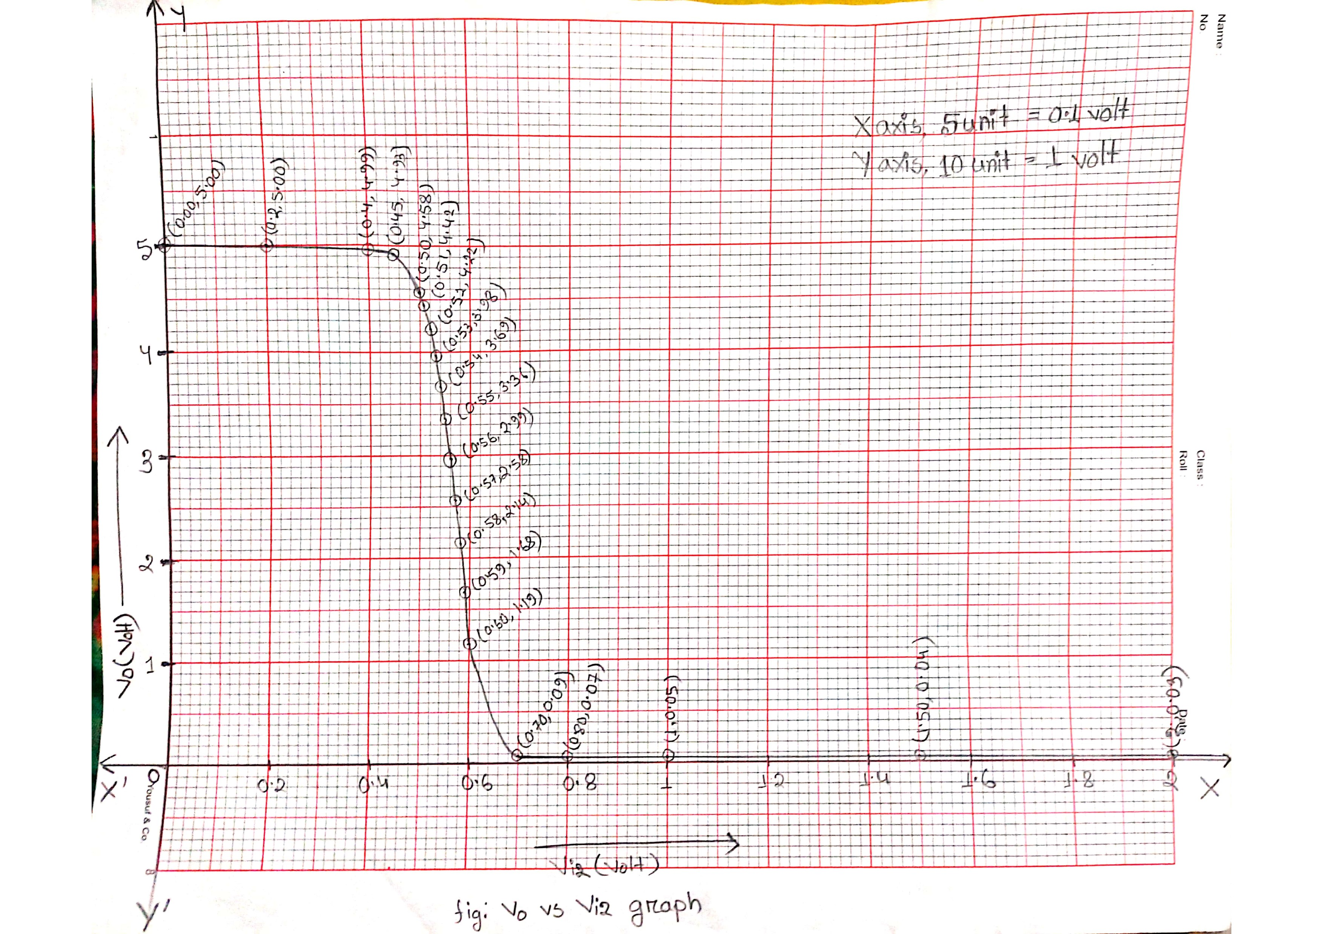

Graph of V0 vs Vi2

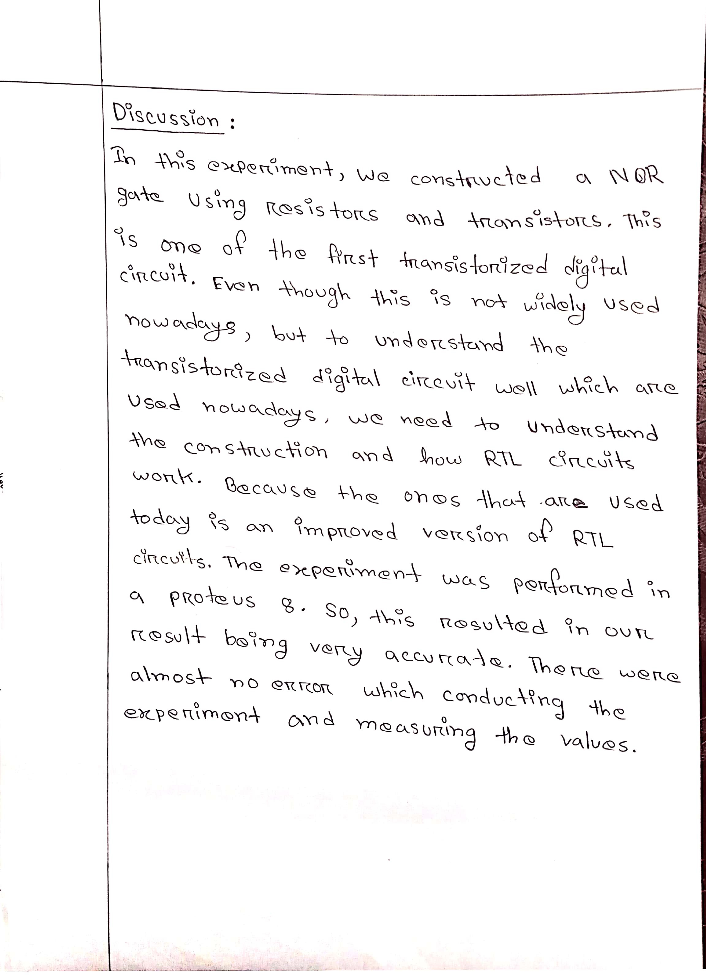

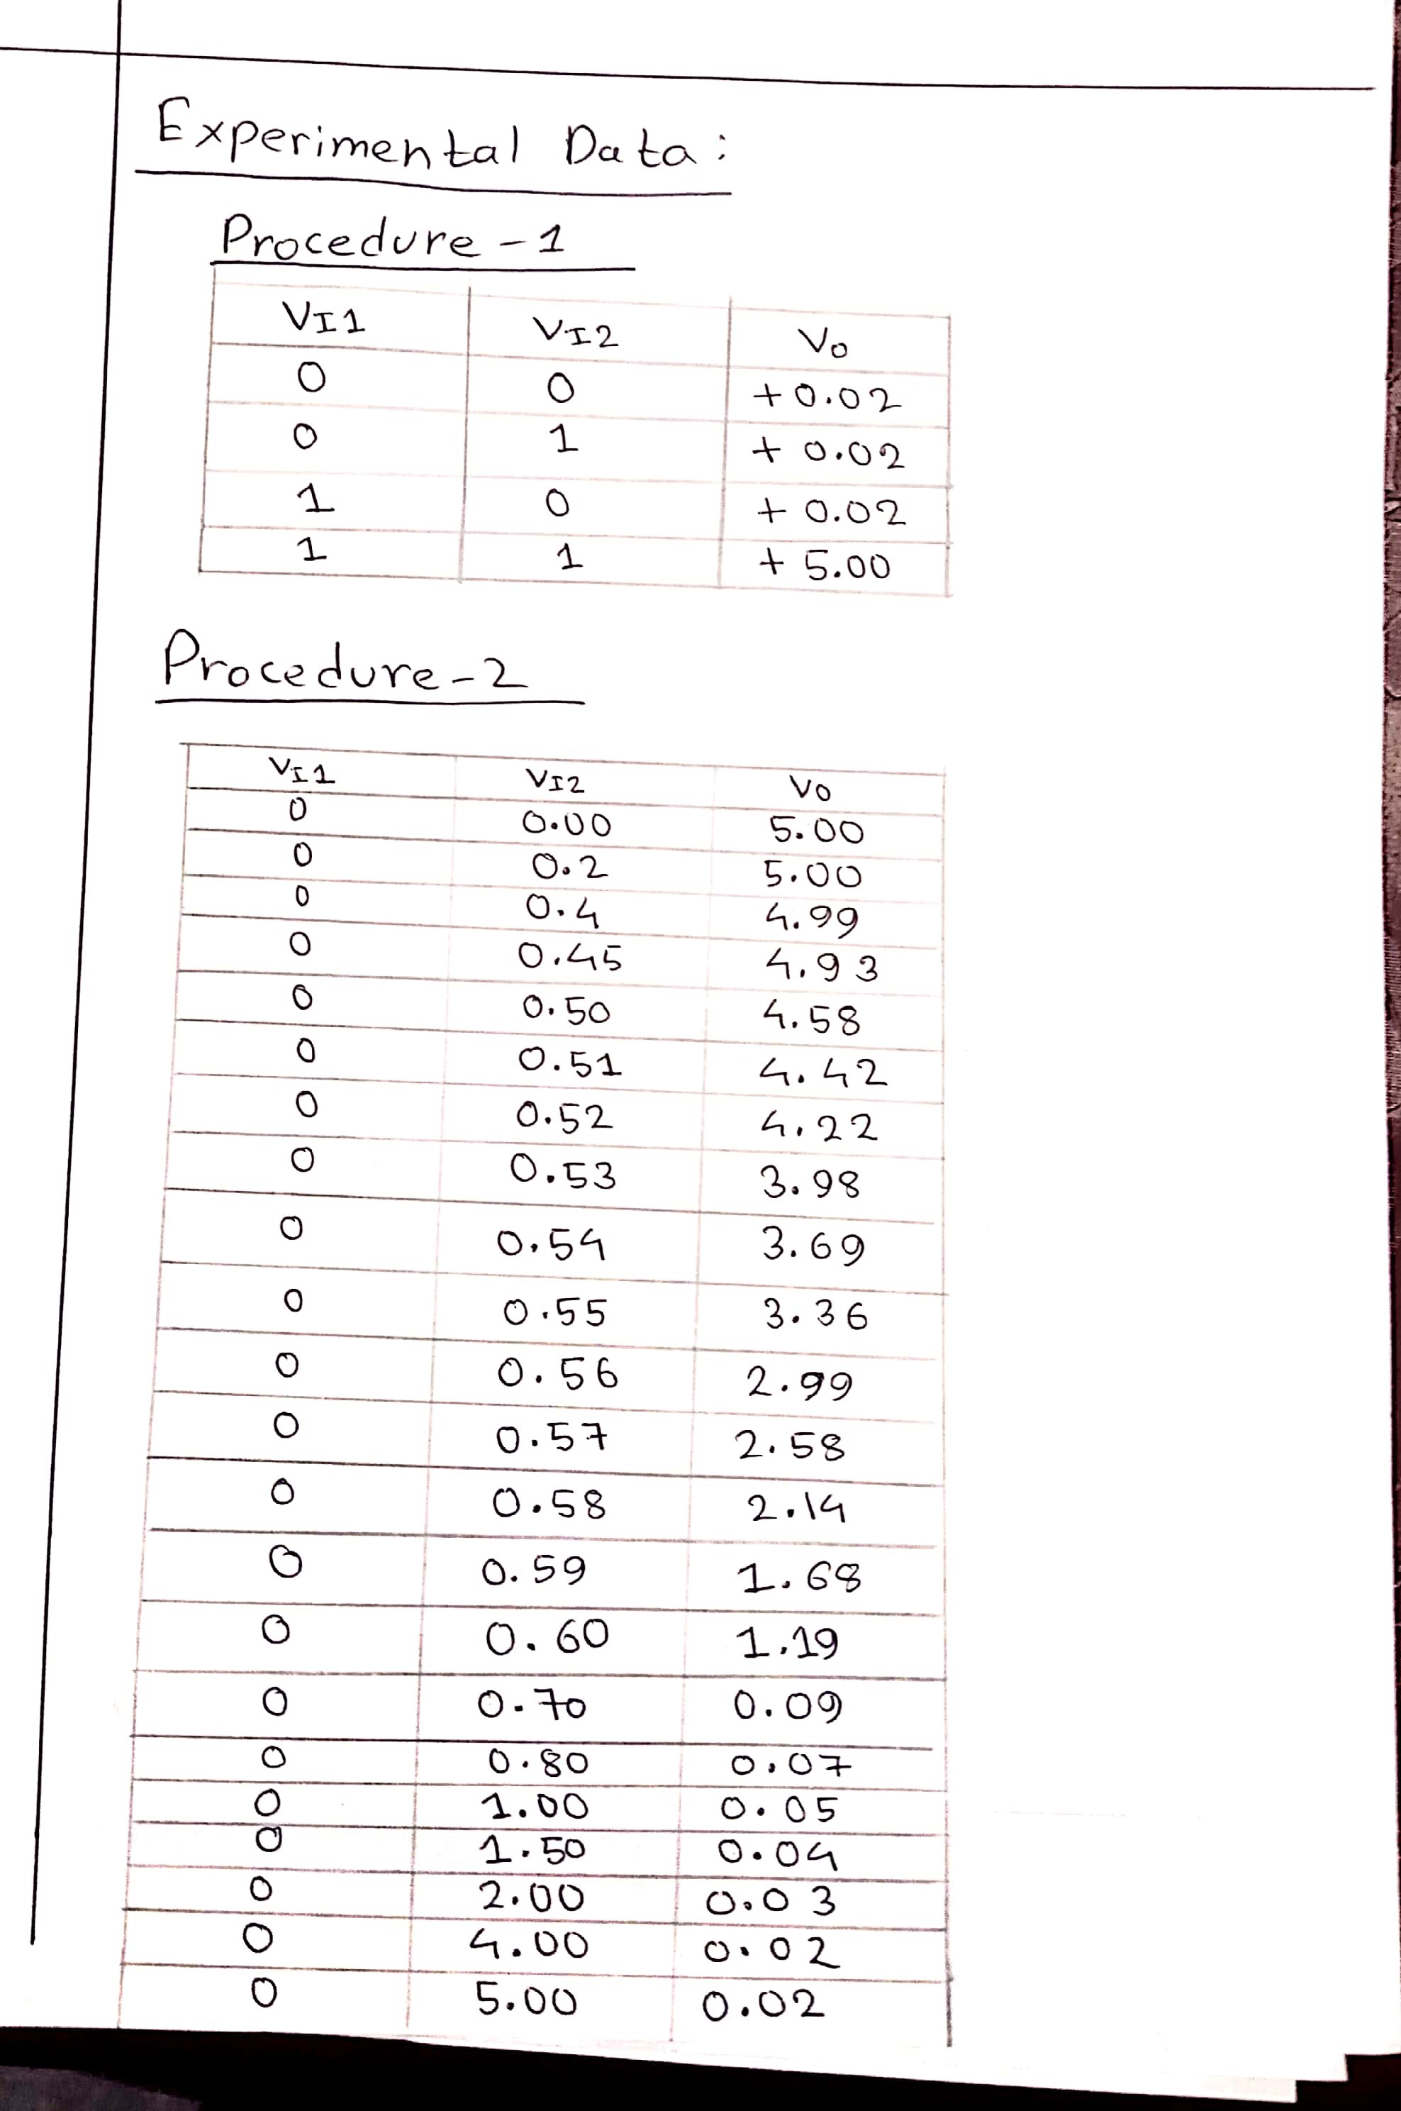

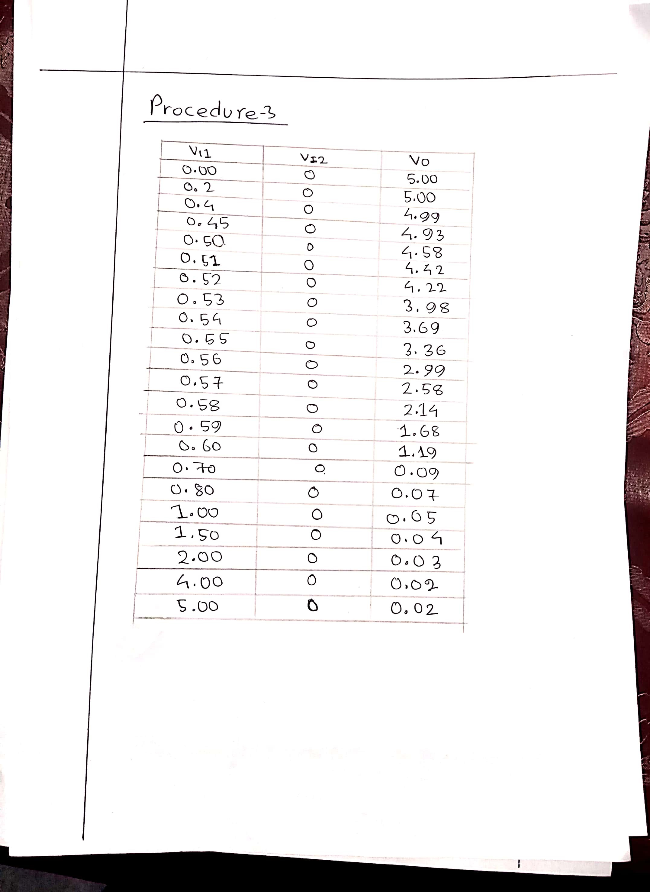

ID 18.01.04.005

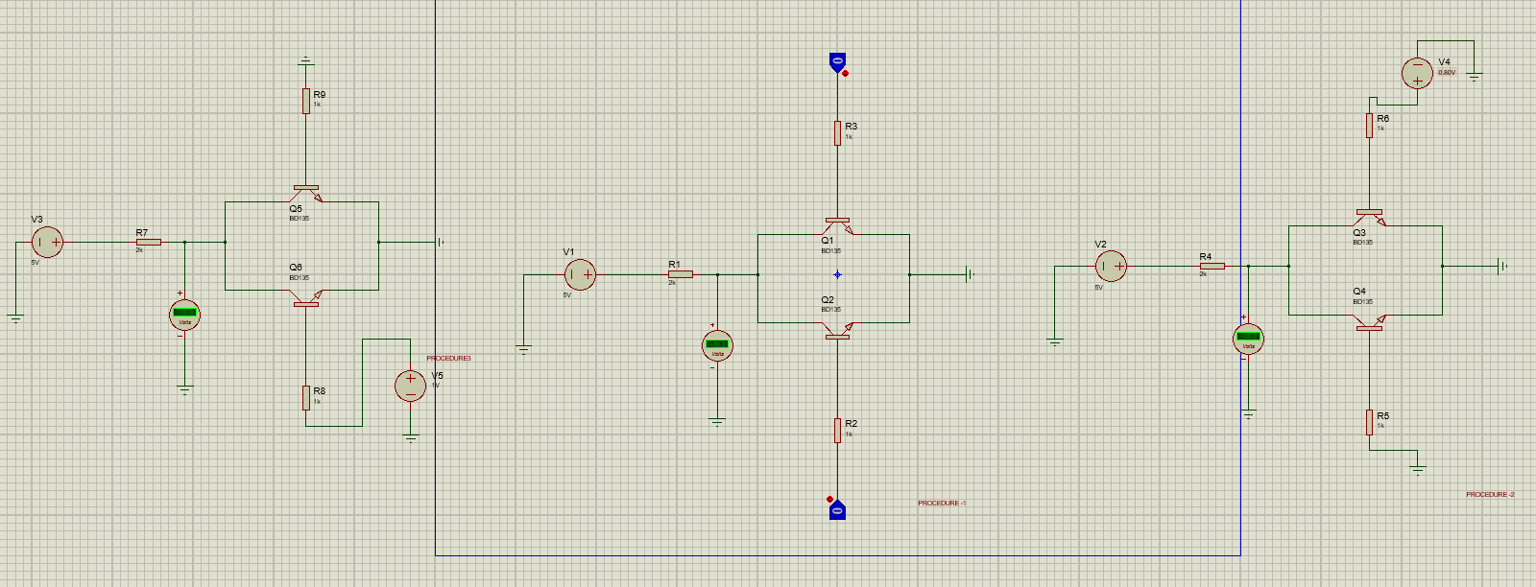

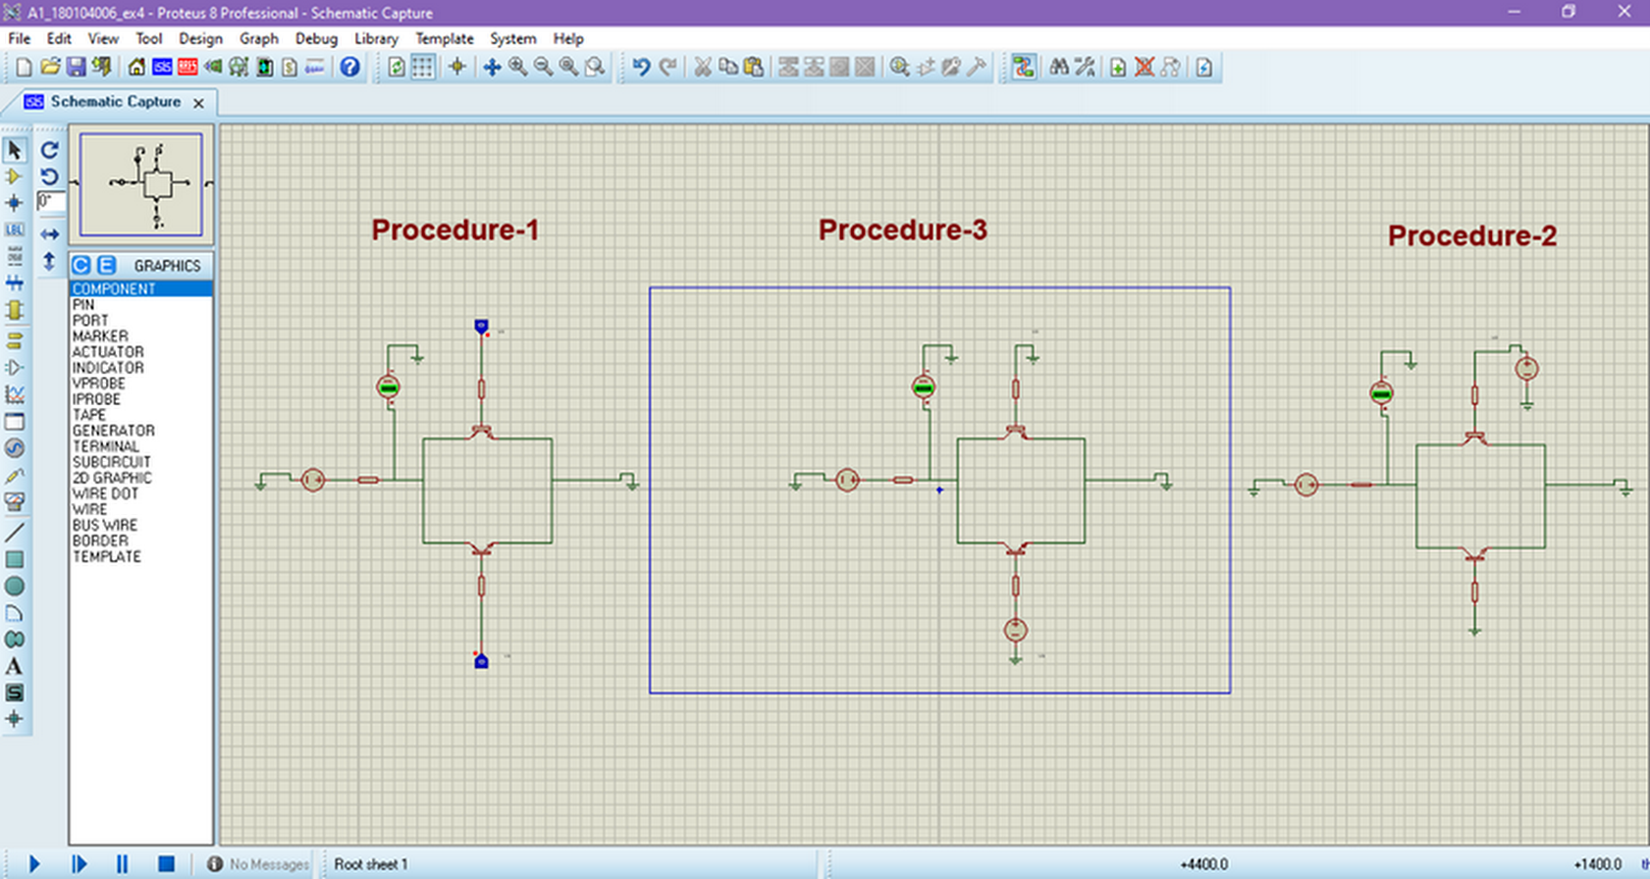

ID 18.01.04.006

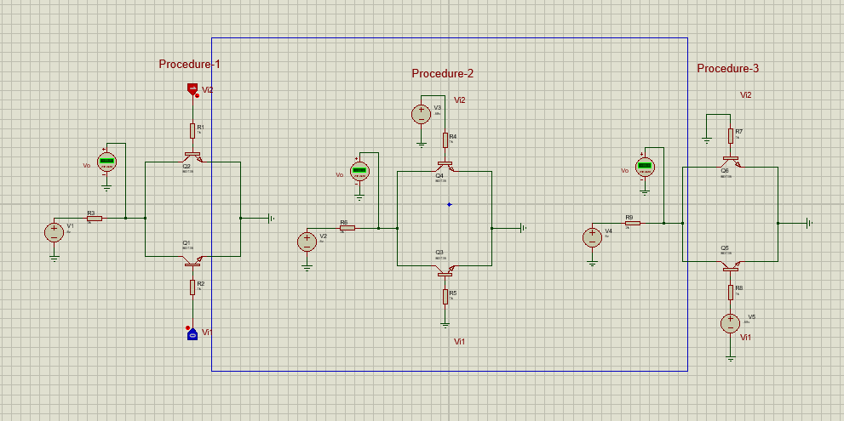

ID 18.01.04.007

**Procedure-1**

ID: 18.01.04.005

|  |  |  |
| --- | --- | --- |
| VI1 | VI2 | VO |
| 0 | 0 | +5.00 |
| 0 | 1 | +0.02 |
| 1 | 0 | +0.02 |
| 1 | 1 | +0.02 |

**Procedure -2**

|  |  |  |
| --- | --- | --- |
| VI1 | VI2 | VO |
| 0 | 0.00 | 5.00 |
| 0 | 0.2 | 5.00 |
| 0 | 0.4 | 4.99 |
| 0 | 0.45 | 4.93 |
| 0 | 0.50 | 4.58 |
| 0 | 0.51 | 4.42 |
| 0 | 0.52 | 4.22 |
| 0 | 0.53 | 3.98 |
| 0 | 0.54 | 3.69 |
| 0 | 0.55 | 3.36 |
| 0 | 0.56 | 2.99 |
| 0 | 0.57 | 2.58 |
| 0 | 0.58 | 2.14 |
| 0 | 0.59 | 1.68 |
| 0 | 0.60 | 1.19 |
| 0 | 0.70 | 0.09 |
| 0 | 0.80 | 0.07 |
| 0 | 1.00 | 0.05 |
| 0 | 1.50 | 0.04 |
| 0 | 2.00 | 0.03 |
| 0 | 4.00 | 0.02 |
| 0 | 5.00 | 0.02 |

**Procedure - 3**

|  |  |  |
| --- | --- | --- |
| VI1 | VI2 | VO |
| 0.00 | 0 | 5.00 |
| 0.2 | 0 | 5.00 |
| 0.4 | 0 | 4.99 |
| 0.45 | 0 | 4.93 |
| 0.50 | 0 | 4.58 |
| 0.51 | 0 | 4.42 |
| 0.52 | 0 | 4.22 |
| 0.53 | 0 | 3.98 |
| 0.54 | 0 | 3.69 |
| 0.55 | 0 | 3.36 |
| 0.56 | 0 | 2.99 |
| 0.57 | 0 | 2.58 |
| 0.58 | 0 | 2.14 |
| 0.59 | 0 | 1.68 |
| 0.60 | 0 | 1.19 |
| 0.70 | 0 | 0.09 |
| 0.80 | 0 | 0.07 |
| 1.00 | 0 | 0.05 |
| 1.50 | 0 | 0.04 |
| 2.00 | 0 | 0.03 |
| 4.00 | 0 | 0.02 |
| 5.00 | 0 | 0.02 |

**Procedure-1**

ID: 18.01.04.006

|  |  |  |
| --- | --- | --- |
| Vi1 | Vi2 | V0 |
| 0 | 0 | 5.00 |
| 0 | 1 | 0.02 |
| 1 | 0 | 0.02 |
| 1 | 1 | 0.02 |

**Procedure -2**

|  |  |  |
| --- | --- | --- |
| Vi1 | Vi2 | V0 |
| 0 | 0.00 | 5.00 |
| 0 | 0.2 | 5.00 |
| 0 | 0.4 | 4.99 |
| 0 | 0.5 | 4.58 |
| 0 | 0.55 | 3.36 |
| 0 | 0.58 | 2.18 |
| 0 | 0.6 | 1.19 |
| 0 | 0.605 | 0.94 |
| 0 | 0.61 | 0.68 |
| 0 | 0.65 | 0.12 |
| 0 | 0.68 | 0.10 |
| 0 | 0.9 | 0.09 |
| 0 | 1.0 | 0.05 |
| 0 | 1.6 | 0.04 |
| 0 | 2.00 | 0.03 |

**Procedure - 3**

|  |  |  |
| --- | --- | --- |
| Vi1 | Vi2 | V0 |
| 0.00 | 0 | 5.00 |
| 0.2 | 0 | 5.00 |
| 0.4 | 0 | 4.99 |
| 0.5 | 0 | 4.58 |
| 0.55 | 0 | 3.36 |
| 0.58 | 0 | 2.18 |
| 0.6 | 0 | 1.19 |
| 0.605 | 0 | 0.94 |
| 0.61 | 0 | 0.68 |
| 0.65 | 0 | 0.12 |
| 0.68 | 0 | 0.10 |
| 0.9 | 0 | 0.09 |
| 1.0 | 0 | 0.05 |
| 1.6 | 0 | 0.04 |
| 2.00 | 0 | 0.03 |

**Procedure-1**

ID: 18.01.04.007

|  |  |  |
| --- | --- | --- |
| Vi1 | Vi2 | Vo |
| 0 | 0 | 5.00 |
| 0 | 1 | 0.02 |
| 1 | 0 | 0.02 |
| 1 | 1 | 0.02 |

**Procedure -2**

|  |  |  |
| --- | --- | --- |
| Vi1 | Vi2 | Vo |
| 0.00 | 0.2 | 5.00 |
| 0.00 | 0.4 | 4.99 |
| 0.00 | 0.48 | 4.78 |
| 0.00 | 0.49 | 4.69 |
| 0.00 | 0.5 | 4.58 |
| 0.00 | 0.55 | 3.36 |
| 0.00 | 0.58 | 2.14 |
| 0.00 | 0.6 | 1.19 |
| 0.00 | 0.62 | 0.21 |
| 0.00 | 0.65 | 0.12 |
| 0.00 | 0.7 | 0.09 |
| 0.00 | 0.8 | 0.07 |
| 0.00 | 1.01 | 0.05 |
| 0.00 | 1.5 | 0.04 |

**Procedure - 3**

|  |  |  |
| --- | --- | --- |
| Vi2 | Vi1 | Vo |
| 0.00 | 0.2 | 5.00 |
| 0.00 | 0.4 | 4.99 |
| 0.00 | 0.5 | 4.58 |
| 0.00 | 0.55 | 3.36 |
| 0.00 | 0.50 | 1.68 |
| 0.00 | 0.58 | 2.14 |
| 0.00 | 0.6 | 1.19 |
| 0.00 | 0.62 | 0.21 |
| 0.00 | 0.65 | 0.12 |
| 0.00 | 0.7 | 0.09 |
| 0.00 | 0.8 | 0.07 |
| 0.00 | 1.01 | 0.05 |